版权归原作者所有
仅供学习交流之用，请勿用于他途

第八章 ALV 控件的使用

ALV（SAP List Viewer）控件是 SAP 业务中最常用的控件之一，本章先用一个简单的例
子介绍用 ALV 控件显示数据，再以实例方式介绍 ALV 的强大功能，示例程序可以直接使用。
本章主要内容有：
（）简单的 ALV 控件实例；
（）自定义输出字段的 ALV 控件实例；
（）在屏幕上建立 ALV 控件；
（）自定义 ALV 控件的工具条按钮；
（）处理 ALV 控件双击事件；
（）通过 ALV 控件编辑内表和数据库更新；
（）ALV Tree 的使用。

8.1 简单的 ALV 控件实例

以航班表（SPFLI）为例，使用数据字典定义结构，通过 ALV 控件显示数据。
【例 8.1】
REPORT YTEST26.
*定义内表
DATA WA_SPFLI LIKE TABLE OF SPFLI WITH HEADER LINE.
*内表赋值
SELECT * INTO TABLE WA_SPFLI FROM SPFLI.
*通过数据字典结构显示ALV
CALL FUNCTION 'REUSE_ALV_LIST_DISPLAY'
EXPORTING
I_STRUCTURE_NAME = 'SPFLI'
TABLES
T_OUTTAB = WA_SPFLI
EXCEPTIONS
PROGRAM_ERROR = 1
OTHERS = 2.
IF SY-SUBRC <> 0.
* MESSAGE ID SY-MSGID TYPE SY-MSGTY NUMBER SY-MSGNO
* WITH SY-MSGV1 SY-MSGV2 SY-MSGV3 SY-MSGV4.
ENDIF.
输出结果如图 8-1 所示。

1

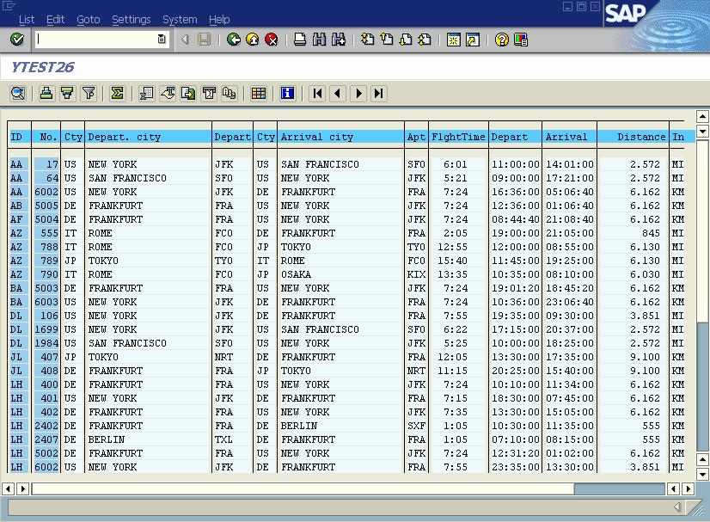
版权归原作者所有

图 8-1
仅供学习交流之用，请勿用于他途

8.2 自定义输出字段的 ALV 控件实例

【例 8.2】
REPORT YTEST27.
*ALV使用到的类库
TYPE-POOLS: SLIS.
*一列描述
DATA WA_ALV_FIELD TYPE SLIS_FIELDCAT_ALV.
*列描述内表，列清单
DATA WA_ALV_FIELDCAT TYPE SLIS_T_FIELDCAT_ALV.
*定义内表
DATA WA_SPFLI LIKE TABLE OF SPFLI WITH HEADER LINE.
*内表赋值
SELECT * INTO TABLE WA_SPFLI FROM SPFLI.

*定义第一到第四个字段
WA_ALV_FIELD-COL_POS = 1.
WA_ALV_FIELD-FIELDNAME = 'CARRID'.
WA_ALV_FIELD-SELTEXT_M = '航线承运人'.
APPEND WA_ALV_FIELD TO WA_ALV_FIELDCAT.

WA_ALV_FIELD-COL_POS = 2.

2

版权归原作者所有

WA_ALV_FIELD-FIELDNAME = 'CONNID'.
WA_ALV_FIELD-SELTEXT_M = '航班连接'.
APPEND WA_ALV_FIELD TO WA_ALV_FIELDCAT.

WA_ALV_FIELD-COL_POS = 3.
WA_ALV_FIELD-FIELDNAME = 'CITYFROM'.
WA_ALV_FIELD-SELTEXT_M = '起飞城市'.
APPEND WA_ALV_FIELD TO WA_ALV_FIELDCAT.

WA_ALV_FIELD-COL_POS = 4.
WA_ALV_FIELD-FIELDNAME = 'CITYTO'.
WA_ALV_FIELD-SELTEXT_M = '目标城市'.
APPEND WA_ALV_FIELD TO WA_ALV_FIELDCAT.

*调用ALV显示表单数据
CALL FUNCTION 'REUSE_ALV_LIST_DISPLAY'
EXPORTING
* I_INTERFACE_CHECK = ' '
* I_BYPASSING_BUFFER =
* I_BUFFER_ACTIVE = ' '
* I_CALLBACK_PROGRAM = ' '
* I_CALLBACK_PF_STATUS_SET = ' '
* I_CALLBACK_USER_COMMAND = ' '
* I_STRUCTURE_NAME =
* IS_LAYOUT =
仅供学习交流之用，请勿用于他途

IT_FIELDCAT = WA_ALV_FIELDCAT
* IT_EXCLUDING =
* IT_SPECIAL_GROUPS =
* IT_SORT =
* IT_FILTER =
* IS_SEL_HIDE =
* I_DEFAULT = 'X'
* I_SAVE = ' '
* IS_VARIANT =
* IT_EVENTS =
* IT_EVENT_EXIT =
* IS_PRINT =
* IS_REPREP_ID =
* I_SCREEN_START_COLUMN = 0
* I_SCREEN_START_LINE = 0
* I_SCREEN_END_COLUMN = 0
* I_SCREEN_END_LINE = 0
* IMPORTING
* E_EXIT_CAUSED_BY_CALLER =

3

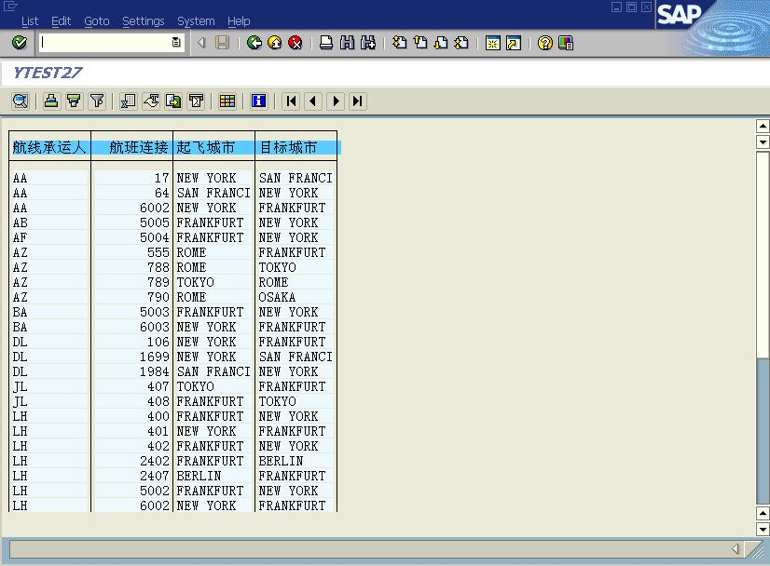
版权归原作者所有

* ES_EXIT_CAUSED_BY_USER =
TABLES
T_OUTTAB = WA_SPFLI
* EXCEPTIONS
* PROGRAM_ERROR = 1
* OTHERS = 2
.
IF SY-SUBRC <> 0.
仅供学习交流之用，请勿用于他途

* MESSAGE ID SY-MSGID TYPE SY-MSGTY NUMBER SY-MSGNO
* WITH SY-MSGV1 SY-MSGV2 SY-MSGV3 SY-MSGV4.
ENDIF.
输出结果如图 8-2 所示。

图 8-2

8.3 在屏幕上建立 ALV 控件

8.3.1 定义 SCREEN 窗口

如图 8-3 所示，在屏幕上创建两个文本元素控件、一个退出按钮控件、一个定制控制控
件。

4

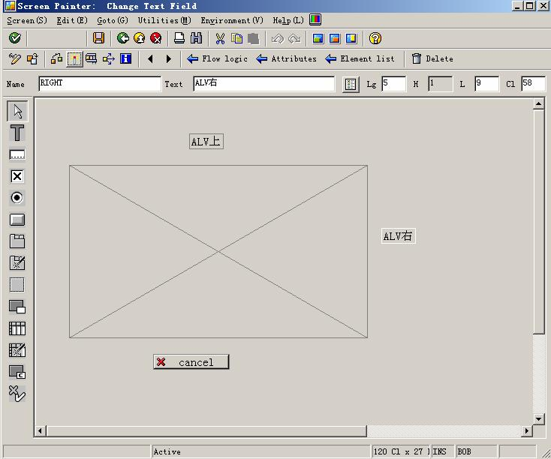
版权归原作者所有

8.3.2 定义逻辑流

逻辑流程序：
*逻辑流
*PBO显示屏幕前的处理
PROCESS BEFORE OUTPUT.
MODULE STATUS_0100.
*PAI用户输入后的处理
PROCESS AFTER INPUT.
MODULE USER_COMMAND_0100.

主程序：
REPORT YTEST28.
*功能码返回值
DATA: OK_CODE TYPE SY-UCOMM,
SAVE_OK TYPE SY-UCOMM.

图 8-3
仅供学习交流之用，请勿用于他途

*定义内表，变量需要传递，不加HEADER LINE
DATA WA_SPFLI TYPE TABLE OF SPFLI .
*内表赋值

5

版权归原作者所有

SELECT * INTO TABLE WA_SPFLI FROM SPFLI.
* ALVDATA 是屏幕100中定义控制控件的名称
仅供学习交流之用，请勿用于他途

DATA: WA_CONTAINER TYPE SCRFNAME VALUE 'ALVDATA',
ALV_GRID TYPE REF TO CL_GUI_ALV_GRID,
WA_CUSTOM_CONTAINER TYPE REF TO CL_GUI_CUSTOM_CONTAINER.
*直接调用窗口
CALL SCREEN 100.

*&---------------------------------------------------------------------*
*& Module STATUS_0100 OUTPUT
*&---------------------------------------------------------------------*
* text
*----------------------------------------------------------------------*
MODULE STATUS_0100 OUTPUT.
SET PF-STATUS 'STATUS1'.
*如果窗口还没有创建ALV对象则创建它
IF WA_CUSTOM_CONTAINER IS INITIAL.
CREATE OBJECT WA_CUSTOM_CONTAINER
EXPORTING
CONTAINER_NAME = WA_CONTAINER.

CREATE OBJECT ALV_GRID
EXPORTING
I_PARENT = WA_CUSTOM_CONTAINER.

CALL METHOD ALV_GRID->SET_TABLE_FOR_FIRST_DISPLAY
EXPORTING
I_STRUCTURE_NAME = 'SPFLI'
CHANGING
IT_OUTTAB = WA_SPFLI.
ENDIF.

ENDMODULE. " STATUS_0100 OUTPUT
*&---------------------------------------------------------------------*
*& Module USER_COMMAND_0100 INPUT
*&---------------------------------------------------------------------*
* text
*----------------------------------------------------------------------*
MODULE USER_COMMAND_0100 INPUT.
SAVE_OK = OK_CODE.
CLEAR OK_CODE.
CASE SAVE_OK.
WHEN 'EXIT'.
LEAVE PROGRAM.

6

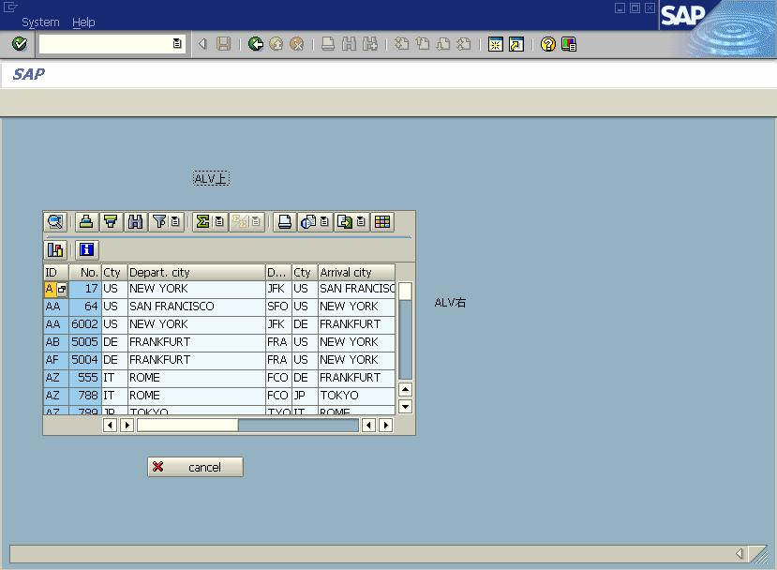
版权归原作者所有

ENDCASE.
仅供学习交流之用，请勿用于他途

ENDMODULE. " USER_COMMAND_0100 INPUT

输出结果如图 8-4 所示。

图 8-4

8.4 自定义 ALV 控件的工具条按钮

在 ALV 的工具条上增加一个自定义的按钮，单击它弹出窗口提示选择行数据内容。执
行结果如图 8-5 所示。

7

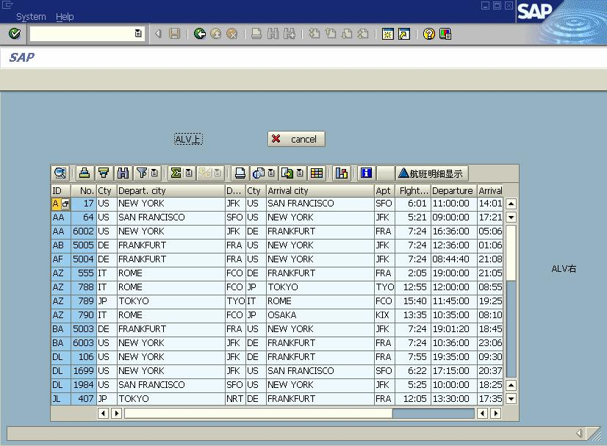
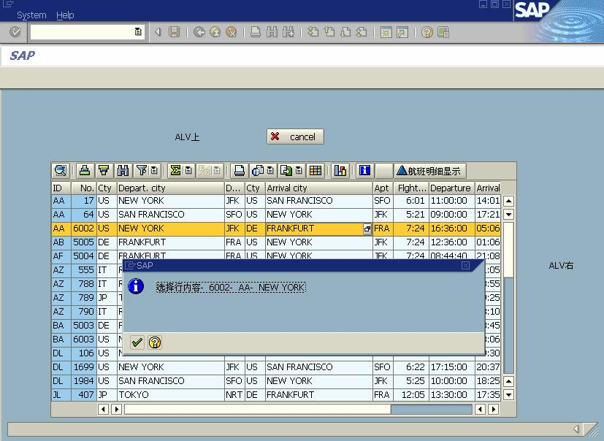
版权归原作者所有

单击自定义按钮后输出如图 8-6 所示。

程序处理流程的说明：

图 8-5

图 8-6

8
仅供学习交流之用，请勿用于他途

版权归原作者所有
仅供学习交流之用，请勿用于他途

定义 ALV 控件相关事件、接口和实现方法等，主要定义以下事件。
（1）ALV 控件的工具条处理事件，定义了新按钮和功能码；
（2）ALV 控件的功能码处理事件，定义用户单击按钮产生的功能码事件。

主程序：
REPORT YTEST29.

INCLUDE <ICON>.

CLASS LCL_EVENT_RECEIVER DEFINITION DEFERRED.

DATA: OK_CODE TYPE SY-UCOMM,
SAVE_OK TYPE SY-UCOMM.

DATA EVENT_RECEIVER TYPE REF TO LCL_EVENT_RECEIVER.

DATA: WA_SPFLI TYPE TABLE OF SPFLI,
A_SPFLI LIKE SPFLI.

SELECT * INTO TABLE WA_SPFLI FROM SPFLI.

DATA: WA_CONTAINER TYPE SCRFNAME VALUE 'ALVDATA',
ALV_GRID TYPE REF TO CL_GUI_ALV_GRID,
WA_CUSTOM_CONTAINER TYPE REF TO CL_GUI_CUSTOM_CONTAINER.

CALL SCREEN 100.

*---------------------------------------------------------------------*
* CLASS lcl_event_receiver DEFINITION
*---------------------------------------------------------------------*
*
*---------------------------------------------------------------------*
CLASS LCL_EVENT_RECEIVER DEFINITION.

PUBLIC SECTION.
METHODS:
HANDLE_TOOLBAR
FOR EVENT TOOLBAR OF CL_GUI_ALV_GRID
IMPORTING E_OBJECT E_INTERACTIVE,

HANDLE_USER_COMMAND
FOR EVENT USER_COMMAND OF CL_GUI_ALV_GRID
IMPORTING E_UCOMM.

9

版权归原作者所有
仅供学习交流之用，请勿用于他途

ENDCLASS. "lcl_event_receiver DEFINITION

*---------------------------------------------------------------------*
* CLASS lcl_event_receiver IMPLEMENTATION
*---------------------------------------------------------------------*
*
*---------------------------------------------------------------------*
CLASS LCL_EVENT_RECEIVER IMPLEMENTATION.

METHOD HANDLE_TOOLBAR.
DATA: LS_TOOLBAR TYPE STB_BUTTON.
CLEAR LS_TOOLBAR-BUTN_TYPE.
APPEND LS_TOOLBAR TO E_OBJECT->MT_TOOLBAR.
CLEAR LS_TOOLBAR.

MOVE 'SHOW_DETA' TO LS_TOOLBAR-FUNCTION.

MOVE ICON_PPE_VNODE TO LS_TOOLBAR-ICON.
MOVE '航班明细显示' TO LS_TOOLBAR-QUICKINFO.
MOVE '航班明细显示'(112) TO LS_TOOLBAR-TEXT.
MOVE '' TO LS_TOOLBAR-DISABLED.
APPEND LS_TOOLBAR TO E_OBJECT->MT_TOOLBAR.
ENDMETHOD. "handle_toolbar

METHOD HANDLE_USER_COMMAND.
DATA: LT_ROWS TYPE LVC_T_ROW.
CASE E_UCOMM.
WHEN 'SHOW_DETA'.
CALL METHOD ALV_GRID->GET_SELECTED_ROWS
IMPORTING
ET_INDEX_ROWS = LT_ROWS.
CALL METHOD CL_GUI_CFW=>FLUSH.
IF SY-SUBRC = 0.
MESSAGE S005(YMESS) WITH '已选择行!'.
PERFORM MESSDETA TABLES LT_ROWS.
ENDIF.
ENDCASE.
ENDMETHOD. "HANDLE_USER_COMMAND
ENDCLASS. "LCL_EVENT_RECEIVER IMPLEMENTATION
*&---------------------------------------------------------------------*
*& Module STATUS_0100 OUTPUT
*&---------------------------------------------------------------------*
* text
*----------------------------------------------------------------------*

10

版权归原作者所有

MODULE STATUS_0100 OUTPUT.
SET PF-STATUS 'STATUS1'.
IF WA_CUSTOM_CONTAINER IS INITIAL.
CREATE OBJECT WA_CUSTOM_CONTAINER
仅供学习交流之用，请勿用于他途

EXPORTING CONTAINER_NAME = WA_CONTAINER.
CREATE OBJECT ALV_GRID
EXPORTING I_PARENT = WA_CUSTOM_CONTAINER.

CALL METHOD ALV_GRID->SET_TABLE_FOR_FIRST_DISPLAY
EXPORTING
I_STRUCTURE_NAME = 'SPFLI'
CHANGING
IT_OUTTAB = WA_SPFLI.

CREATE OBJECT EVENT_RECEIVER.
SET HANDLER EVENT_RECEIVER->HANDLE_USER_COMMAND FOR ALV_GRID.

SET HANDLER EVENT_RECEIVER->HANDLE_TOOLBAR FOR ALV_GRID.
CALL METHOD ALV_GRID->SET_TOOLBAR_INTERACTIVE.
ENDIF.
ENDMODULE. " STATUS_0100 OUTPUT
*&---------------------------------------------------------------------*
*& Module USER_COMMAND_0100 INPUT
*&---------------------------------------------------------------------*
* text
*----------------------------------------------------------------------*
MODULE USER_COMMAND_0100 INPUT.
SAVE_OK = OK_CODE.
CLEAR OK_CODE.
CASE SAVE_OK.
WHEN 'EXIT'.
LEAVE PROGRAM.
ENDCASE.
ENDMODULE. " USER_COMMAND_0100 INPUT
*&---------------------------------------------------------------------*
*& Form MESSDETA
*&---------------------------------------------------------------------*
* text
*----------------------------------------------------------------------*
* -->P_LT_ROWS text
*----------------------------------------------------------------------*
FORM MESSDETA TABLES P_ET_INDEX_ROWS STRUCTURE LVC_S_ROW.
"Insert correct name for <...>.
DATA: LS_SELECTED_LINE LIKE LVC_S_ROW,

11

版权归原作者所有

LF_ROW_INDEX TYPE LVC_INDEX.

DATA: S1(200) TYPE C,
S2(3) TYPE C.

S2 = '-'.
仅供学习交流之用，请勿用于他途

LOOP AT P_ET_INDEX_ROWS INTO LS_SELECTED_LINE.
LF_ROW_INDEX = LS_SELECTED_LINE-INDEX.

READ TABLE WA_SPFLI INDEX LF_ROW_INDEX INTO A_SPFLI.

S1 = '选择行内容'.
CONCATENATE S1 A_SPFLI-CONNID A_SPFLI-CARRID A_SPFLI-CITYFROM
INTO S1 SEPARATED BY S2.
MESSAGE I005(YMESS) WITH S1.
ENDLOOP.
ENDFORM. " MESSDETA

8.5 处理 ALV 双击事件

【例 8.3】
主程序：
REPORT YTEST30.
*功能码返回值
DATA: OK_CODE TYPE SY-UCOMM,
SAVE_OK TYPE SY-UCOMM.
*定义内表，变量需要传递，不加HEADER LINE
DATA WA_SPFLI TYPE TABLE OF SPFLI.
*内表赋值
SELECT * INTO TABLE WA_SPFLI FROM SPFLI.
*定义窗口定制控制,定义ALV对象
DATA: WA_CONTAINER TYPE SCRFNAME VALUE 'ALVDATA',
ALV_GRID TYPE REF TO CL_GUI_ALV_GRID,
WA_CUSTOM_CONTAINER TYPE REF TO CL_GUI_CUSTOM_CONTAINER.
*定义事件类型
CLASS LCL_EVENT_RECEIVER DEFINITION DEFERRED.
*定义事件
DATA EVENT_RECEIVER TYPE REF TO LCL_EVENT_RECEIVER.
*直接调用窗口
CALL SCREEN 100.

*---------------------------------------------------------------------*
* CLASS lcl_event_receiver DEFINITION

12

版权归原作者所有
仅供学习交流之用，请勿用于他途

*---------------------------------------------------------------------*
* 定义事件的属性和方法
*---------------------------------------------------------------------*
CLASS LCL_EVENT_RECEIVER DEFINITION.
PUBLIC SECTION.
METHODS:
HANDLE_DOUBLE_CLICK
FOR EVENT DOUBLE_CLICK OF CL_GUI_ALV_GRID
IMPORTING E_ROW E_COLUMN.
ENDCLASS. "lcl_event_receiver DEFINITION

*---------------------------------------------------------------------*
* CLASS lcl_event_receiver IMPLENTATION
*---------------------------------------------------------------------*
* 双击方法实现
*---------------------------------------------------------------------*
CLASS LCL_EVENT_RECEIVER IMPLEMENTATION.
METHOD HANDLE_DOUBLE_CLICK.
DATA: LI_SPFLI LIKE LINE OF WA_SPFLI.
READ TABLE WA_SPFLI INDEX E_ROW-INDEX INTO LI_SPFLI.
*将行列等信息合并到字符串
DATA: S1(100) TYPE C.
CONCATENATE '行:' E_ROW-INDEX '列名:' E_COLUMN-FIELDNAME INTO S1.
CONCATENATE S1 'connid:' LI_SPFLI-CONNID INTO S1.
CONCATENATE S1 'carrid:' LI_SPFLI-CARRID INTO S1.
*在状态条显示单击的行与列信息
MESSAGE S208(00) WITH S1.
ENDMETHOD. "handle_double_click
ENDCLASS. "lcl_event_receiver IMPLENTATION
*&---------------------------------------------------------------------*
*& Module STATUS_0100 OUTPUT
*&---------------------------------------------------------------------*
* 定义状态条、包括菜单、工具条按钮、系统按钮等
*----------------------------------------------------------------------*
MODULE STATUS_0100 OUTPUT.
SET PF-STATUS 'STATUS1'.
*如果窗口还没有创建ALV对象则创建它
IF WA_CUSTOM_CONTAINER IS INITIAL.
CREATE OBJECT WA_CUSTOM_CONTAINER
EXPORTING CONTAINER_NAME = WA_CONTAINER.
CREATE OBJECT ALV_GRID
EXPORTING I_PARENT = WA_CUSTOM_CONTAINER.
CALL METHOD ALV_GRID->SET_TABLE_FOR_FIRST_DISPLAY
EXPORTING

13

版权归原作者所有

I_STRUCTURE_NAME = 'SPFLI'
CHANGING
IT_OUTTAB = WA_SPFLI.
*ALV对象分配双击事件
CREATE OBJECT EVENT_RECEIVER.
仅供学习交流之用，请勿用于他途

SET HANDLER EVENT_RECEIVER->HANDLE_DOUBLE_CLICK
FOR ALV_GRID.
ENDIF.
ENDMODULE. " STATUS_0100 OUTPUT
*&---------------------------------------------------------------------*
*& Module USER_COMMAND_0100 INPUT
*&---------------------------------------------------------------------*
* 用户交互
*----------------------------------------------------------------------*
MODULE USER_COMMAND_0100 INPUT.
SAVE_OK = OK_CODE.
CLEAR OK_CODE.
CASE SAVE_OK.
WHEN 'EXIT'.
LEAVE PROGRAM.
ENDCASE.
ENDMODULE. " USER_COMMAND_0100 INPUT
输出界面如图 8-7 所示。双击时，注意状态条显示的信息：行号、选中列名、
航班表中的 CONNID 和 CARRID 的值。

14

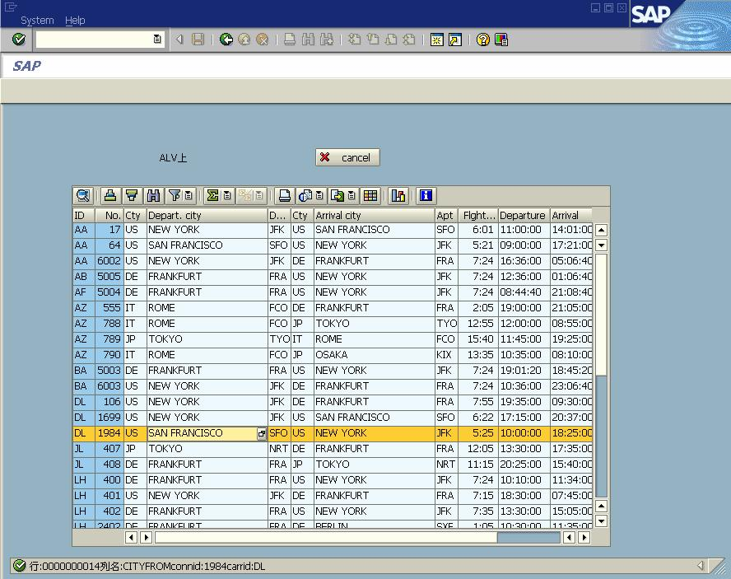
版权归原作者所有

图 8-7
仅供学习交流之用，请勿用于他途

8.6 通过 ALV 控件编辑内表和数据库更新

处理过程如下：
（1）设定 ALV 控件可以编辑；
（2）退出屏幕时将数据更新到内表；
（3）捕捉 ALV 控件的数据更改信息，将 ALV 控件的删除行信息保存到内表中；
（4）在输出时，比较删除行和最后的内表，删除重复的行；
（5）将数据更新到数据表。
【例 8.4】
主程序：
REPORT YTEST31.
DATA: OK_CODE TYPE SY-UCOMM,
SAVE_OK TYPE SY-UCOMM.
TABLES SPFLI.

DATA LS_SPFLI TYPE SPFLI.

DATA WA_SPFLI TYPE TABLE OF SPFLI.

DATA WADEL_SPFLI TYPE TABLE OF SPFLI.

15

版权归原作者所有

SELECT * INTO TABLE WA_SPFLI FROM SPFLI.
仅供学习交流之用，请勿用于他途

DATA: WA_CONTAINER TYPE SCRFNAME VALUE 'ALVDATA',
ALV_GRID TYPE REF TO CL_GUI_ALV_GRID,
WA_CUSTOM_CONTAINER TYPE REF TO CL_GUI_CUSTOM_CONTAINER.

DATA WA_LAYOUT TYPE LVC_S_LAYO.
WA_LAYOUT-EDIT = 'X'.
CLASS LCL_EVENT_RECEIVER DEFINITION DEFERRED.

DATA EVENT_RECEIVER TYPE REF TO LCL_EVENT_RECEIVER.

*---------------------------------------------------------------------*
* CLASS lcl_event_receiver DEFINITION
*---------------------------------------------------------------------*
*
*---------------------------------------------------------------------*
CLASS LCL_EVENT_RECEIVER DEFINITION.

PUBLIC SECTION.
TYPES: DEL_ROWS TYPE STANDARD TABLE OF SPFLI.
DATA: DDEL_ROWS TYPE STANDARD TABLE OF SPFLI.

METHODS:
HANDLE_DATA_CHANGED
FOR EVENT DATA_CHANGED OF CL_GUI_ALV_GRID
IMPORTING ER_DATA_CHANGED.

METHODS:
UPDATE_DELTA_TABLES
IMPORTING
PR_DATA_CHANGED TYPE REF TO CL_ALV_CHANGED_DATA_PROTOCOL.

METHODS:
GET_DELETED_ROWS
EXPORTING
DELETED_ROWS TYPE DEL_ROWS.
ENDCLASS. "LCL_EVENT_RECEIVER DEFINITION
*---------------------------------------------------------------------*
* CLASS LCL_EVENT_RECEIVER IMPLEMENTATION
*---------------------------------------------------------------------*
*
*---------------------------------------------------------------------*

16

版权归原作者所有

CLASS LCL_EVENT_RECEIVER IMPLEMENTATION.

METHOD HANDLE_DATA_CHANGED.
仅供学习交流之用，请勿用于他途

CALL METHOD UPDATE_DELTA_TABLES( ER_DATA_CHANGED ).
ENDMETHOD. "HANDLE_DATA_CHANGED

METHOD UPDATE_DELTA_TABLES.

DATA: L_DEL_ROW TYPE LVC_S_MOCE.

LOOP AT PR_DATA_CHANGED->MT_DELETED_ROWS INTO L_DEL_ROW.
READ TABLE WA_SPFLI INTO LS_SPFLI INDEX L_DEL_ROW-ROW_ID.
IF SY-SUBRC NE 0.
MESSAGE E208(00) WITH '处理错误'.
ELSE.
APPEND LS_SPFLI TO DDEL_ROWS.
ENDIF.
ENDLOOP.
ENDMETHOD. "update_delta_tables
METHOD GET_DELETED_ROWS.
DELETED_ROWS = ME->DDEL_ROWS.
ENDMETHOD. "get_deleted_rows
ENDCLASS. "LCL_EVENT_RECEIVER DEFINITION

START-OF-SELECTION.
CALL SCREEN 100.
WRITE / '删除的内表记录'.
WRITE / '______________'.
CALL METHOD EVENT_RECEIVER->GET_DELETED_ROWS
IMPORTING
DELETED_ROWS = WADEL_SPFLI.

LOOP AT WADEL_SPFLI INTO SPFLI.
WRITE: / SPFLI-CARRID,SPFLI-CONNID,SPFLI-CITYFROM.
ENDLOOP.

WRITE: / '更新后的内表记录：'.
WRITE: / '__________________'.
LOOP AT WA_SPFLI INTO SPFLI.
WRITE : / SPFLI-CARRID,SPFLI-CONNID,SPFLI-CITYFROM.
ENDLOOP.

*WHEN 'SAVE'.
* MODIFY SPFLI FORM TABLE WA_SPFLI.

17

版权归原作者所有

*
* IF SY-SUBRC NE 0.
仅供学习交流之用，请勿用于他途

* MESSAGE I005(YMESS) WITH '更新数据错误！'.
* EXIT.
* ELSE.
* MESSAGE I005(YMESS) WITH '更新数据OK！'.
* ENDIF.
* DELETE SPFLI FROM TABLE DELA_SPFLI.
* IF SY-SUBRC NE 0.
* MESSAGE I005(YMESS) WITH '更新数据错误！'.
* ELSE.
* MESSAGE I005(YMESS) WITH '更新数据OK！'.
* ENDIF.

END-OF-SELECTION.
*&---------------------------------------------------------------------*
*& Module STATUS_0100 OUTPUT
*&---------------------------------------------------------------------*
* text
*----------------------------------------------------------------------*
MODULE STATUS_0100 OUTPUT.
SET PF-STATUS 'STATUS1'.
IF WA_CUSTOM_CONTAINER IS INITIAL.
CREATE OBJECT WA_CUSTOM_CONTAINER
EXPORTING CONTAINER_NAME = WA_CONTAINER.
CREATE OBJECT ALV_GRID
EXPORTING I_PARENT = WA_CUSTOM_CONTAINER.

CREATE OBJECT EVENT_RECEIVER.
SET HANDLER EVENT_RECEIVER->HANDLE_DATA_CHANGED FOR ALV_GRID.

CALL METHOD ALV_GRID->SET_TABLE_FOR_FIRST_DISPLAY
EXPORTING
I_STRUCTURE_NAME = 'SPFLI'
IS_LAYOUT = WA_LAYOUT
CHANGING
IT_OUTTAB = WA_SPFLI.
ENDIF.

ENDMODULE. " STATUS_0100 OUTPUT
*&---------------------------------------------------------------------*
*& Module USER_COMMAND_0100 INPUT
*&---------------------------------------------------------------------*
* text

18

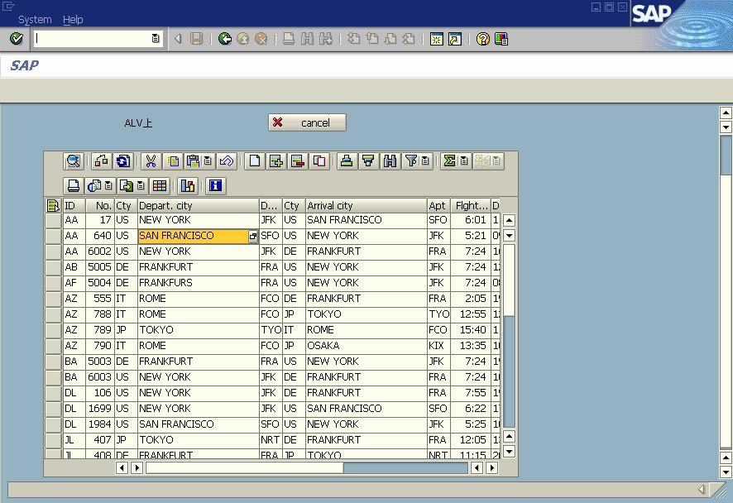
版权归原作者所有
仅供学习交流之用，请勿用于他途

*----------------------------------------------------------------------*
MODULE USER_COMMAND_0100 INPUT.
SAVE_OK = OK_CODE.
CLEAR OK_CODE.
CASE SAVE_OK.
WHEN 'EXIT'.
DATA L_RET VALUE 'X'.
CALL METHOD ALV_GRID->CHECK_CHANGED_DATA
IMPORTING
E_VALID = L_RET.
LEAVE TO SCREEN 0.
ENDCASE.
ENDMODULE. " USER_COMMAND_0100
INPUT

图 8-8
再删除两行后退出，输出结果如图 8-9 所示。

19

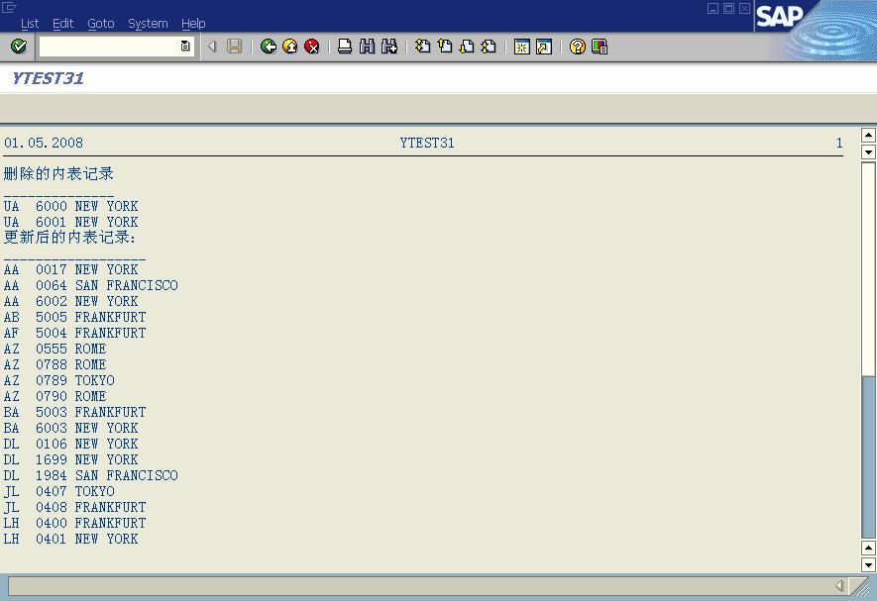
版权归原作者所有

注：更新到数据库程序是被注释的。

8.7 ALV Tree 的使用

图 8-9
仅供学习交流之用，请勿用于他途

在 SAP 业务系统中，大量地使用到了 ALV Tree 对象，该对象在表格基础上对同类数据
进行归类，并对各分类能进行数据汇总，如图 8-10 所示。

20

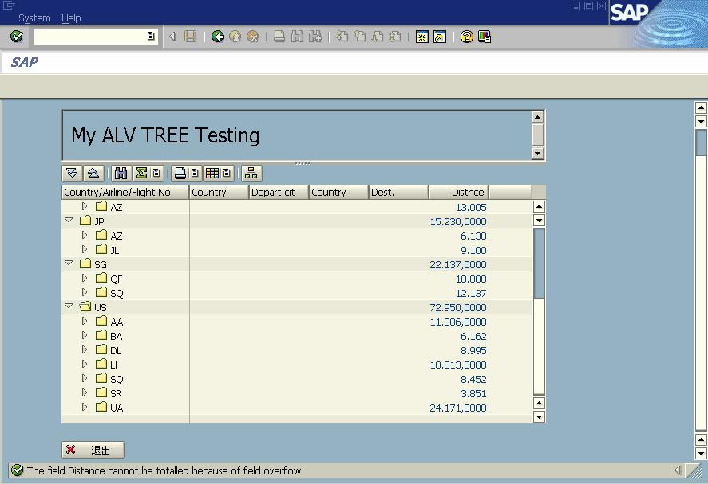
版权归原作者所有

以航班表（SPFLI）为例：
（1）按国家、航线、航班分类；

图 8-10
仅供学习交流之用，请勿用于他途

（2）在右半屏对距离字段进行数量汇总；
（3）在右屏输出起飞国家、起飞城市、目的国家、目的城市、距离字段，并控制其输出长
度。
处理过程：
（1）建立程序和屏幕，在屏幕上建立定制控制对象，定义好工作流；
（2）建立好 PAI、PBO 事件；
（3）在 PAI 中定义建立定制控制对象，并建立 AVL Tree 对象；
（4）建立 ALV Tree 对象的标题；
（5）建立右屏输出字段清单、字段长度、汇总字段等内容；
（6）建立 Tree 分类字段清单及输出先后顺序；
（7）显示 ALV Tree 对象。
主程序：
REPORT YTEST32.
DATA: OK_CODE TYPE SY-UCOMM,
SAVE_OK TYPE SY-UCOMM.

DATA: GB_FIELDCAT TYPE LVC_T_FCAT.
DATA: GB_SORTFLD TYPE LVC_T_SORT.

DATA WA_SPFLI TYPE TABLE OF SPFLI.

SELECT * INTO TABLE WA_SPFLI FROM SPFLI.

21

版权归原作者所有
仅供学习交流之用，请勿用于他途

DATA: WA_CONTAINER TYPE SCRFNAME VALUE 'ALVDATA',
ALV_GRID TYPE REF TO CL_GUI_ALV_TREE_SIMPLE,
WA_CUSTOM_CONTAINER TYPE REF TO CL_GUI_CUSTOM_CONTAINER.

CALL SCREEN 100.
*&---------------------------------------------------------------------*
*& Module STATUS_0100 OUTPUT
*&---------------------------------------------------------------------*
* text
*----------------------------------------------------------------------*
MODULE STATUS_0100 OUTPUT.
SET PF-STATUS 'STATUS1'.
IF WA_CUSTOM_CONTAINER IS INITIAL.
DATA LS_LIST_COMM TYPE SLIS_T_LISTHEADER.
DATA LS_ALIST_COMM TYPE SLIS_LISTHEADER.
LS_ALIST_COMM-TYP = 'H'.
LS_ALIST_COMM-INFO = 'My ALV TREE Testing'.
APPEND LS_ALIST_COMM TO LS_LIST_COMM.

PERFORM BLDCAT.
PERFORM BLDSORTFLD.

CREATE OBJECT WA_CUSTOM_CONTAINER
EXPORTING CONTAINER_NAME = WA_CONTAINER.

CREATE OBJECT ALV_GRID
EXPORTING I_PARENT = WA_CUSTOM_CONTAINER.

CALL METHOD ALV_GRID->SET_TABLE_FOR_FIRST_DISPLAY
EXPORTING
IT_LIST_COMMENTARY = LS_LIST_COMM
I_STRUCTURE_NAME = 'SPFLI'
CHANGING
IT_SORT = GB_SORTFLD
IT_FIELDCATALOG = GB_FIELDCAT
IT_OUTTAB = WA_SPFLI.

CALL METHOD ALV_GRID->EXPAND_TREE
EXPORTING
I_LEVEL = 1.
ENDIF.
ENDMODULE. " STATUS_0100 OUTPUT
*&---------------------------------------------------------------------*

22

版权归原作者所有

*& Module USER_COMMAND_0100 INPUT
仅供学习交流之用，请勿用于他途

*&---------------------------------------------------------------------*
* text
*----------------------------------------------------------------------*
MODULE USER_COMMAND_0100 INPUT.
SAVE_OK = OK_CODE.
CLEAR OK_CODE.
CASE SAVE_OK.
WHEN 'EXIT'.
LEAVE PROGRAM.
ENDCASE.

ENDMODULE. " USER_COMMAND_0100 INPUT
*&---------------------------------------------------------------------*
*& Form BLDCAT
*&---------------------------------------------------------------------*
* text
*----------------------------------------------------------------------*
* --> p1 text
* <-- p2 text
*----------------------------------------------------------------------*
FORM BLDCAT .
CALL FUNCTION 'LVC_FIELDCATALOG_MERGE'
EXPORTING
I_STRUCTURE_NAME = 'SPFLI'
CHANGING
CT_FIELDCAT = GB_FIELDCAT.

DATA LS_FLDCAT TYPE LVC_S_FCAT.
LOOP AT GB_FIELDCAT INTO LS_FLDCAT.
CASE LS_FLDCAT-FIELDNAME.
WHEN 'COUNTRYFR' OR 'CITYFROM' OR 'COUNTRYTO'
OR 'CITYTO' OR 'DISTANCE'.
LS_FLDCAT-OUTPUTLEN = 15.
WHEN OTHERS.
LS_FLDCAT-NO_OUT = 'X'.
ENDCASE.

IF LS_FLDCAT-FIELDNAME = 'DISTANCE'.
LS_FLDCAT-DO_SUM = 'X'.
ENDIF.
MODIFY GB_FIELDCAT FROM LS_FLDCAT.
ENDLOOP.

23

版权归原作者所有

ENDFORM. " BLDCAT
仅供学习交流之用，请勿用于他途

*&---------------------------------------------------------------------*
*& Form BLDSORTFLD
*&---------------------------------------------------------------------*
* text
*----------------------------------------------------------------------*
* --> p1 text
* <-- p2 text
*----------------------------------------------------------------------*
FORM BLDSORTFLD .
DATA LS_SORTFLD TYPE LVC_S_SORT.

LS_SORTFLD-SPOS = 1.
LS_SORTFLD-FIELDNAME = 'COUNTRYFR'.
LS_SORTFLD-UP = 'X'.
LS_SORTFLD-SUBTOT = 'X'.
APPEND LS_SORTFLD TO GB_SORTFLD.

LS_SORTFLD-SPOS = 2.
LS_SORTFLD-FIELDNAME = 'CARRID'.
LS_SORTFLD-UP = 'X'.
LS_SORTFLD-SUBTOT = 'X'.
APPEND LS_SORTFLD TO GB_SORTFLD.

LS_SORTFLD-SPOS = 3.
LS_SORTFLD-FIELDNAME = 'CONNID'.
LS_SORTFLD-UP = 'X'.
LS_SORTFLD-SUBTOT = 'X'.
APPEND LS_SORTFLD TO GB_SORTFLD.
ENDFORM. " BLDSORTFLD
逻辑流程序：
PROCESS BEFORE OUTPUT.
MODULE STATUS_0100.

PROCESS AFTER INPUT.
MODULE USER_COMMAND_0100.

24

